**Project Design Phase-II**

|  |  |
| --- | --- |
| **Date** | **24 June 2025** |
| **Team ID** | **LTVIP2025TMID35513** |
| **Project Name** | **pattern sense: classifying fabric patterns using deep learning** |
| **Mentor Name** | **Dr Shaik Salma Begam** |
| **Maximum Marks** | **4 Marks** |

**Data Flow Diagram & User Stories**

**Data Flow Diagram (DFD)**

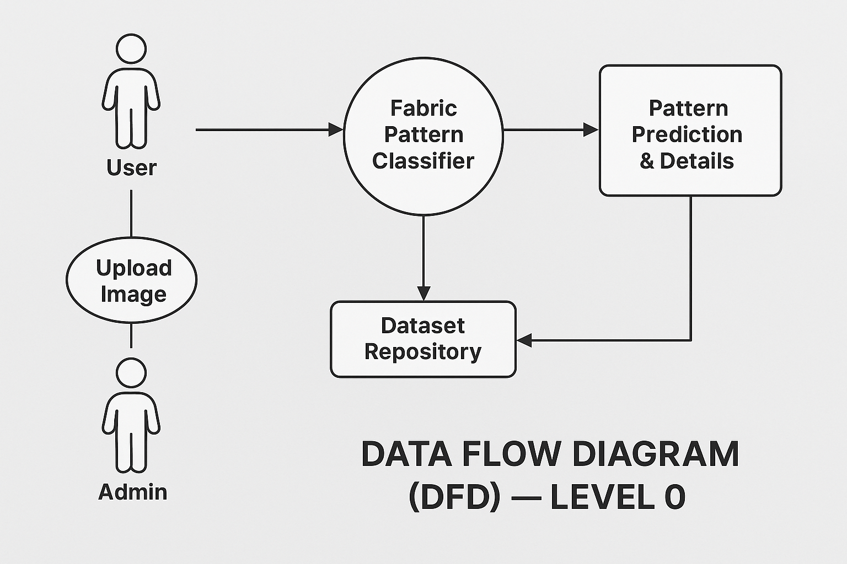

**Description:**

* Users can upload fabric images for pattern classification.
* Deep learning model classifies the fabric pattern and provides detailed information.
* Admin manages datasets and updates models to improve accuracy.
* System provides feedback and maintains logs for monitoring.

|  |  |  |  |  |  |  |
| --- | --- | --- | --- | --- | --- | --- |
| **User Type** | **Functional Requirement (Epic)** | **User Story Number** | **User Story / Task** | **Acceptance Criteria** | **Priority** | Release |
| User (Mobile/Web) | Fabric Image Upload | USN-1 | As a user, I can upload fabric images to the platform for classification. | I can successfully upload images. | High | Sprint-1 |
| User (Mobile/Web) | Classification Result | USN-2 | As a user, I can view predicted fabric pattern categories after uploading an image. | I can see the predicted pattern. | High | Sprint-1 |
| User (Mobile/Web) | View Pattern Details | USN-3 | As a user, I can see detailed information (pattern name, description, usage suggestions). | I can access detailed pattern info. | Medium | Sprint-1 |
| Admin | Dataset Management | USN-4 | As an admin, I can add, edit, and manage fabric pattern datasets used for training the model. | Admin can manage dataset successfully. | High | Sprint-1 |
| Admin | Model Monitoring & Update | USN-5 | As an admin, I can monitor model performance and upload new versions of the model if needed. | Model status and update logs available. | High | Sprint-2 |
| Admin | User Management | USN-6 | As an admin, I can view and manage registered users and their uploads. | Can manage users and view uploads. | Medium |  |